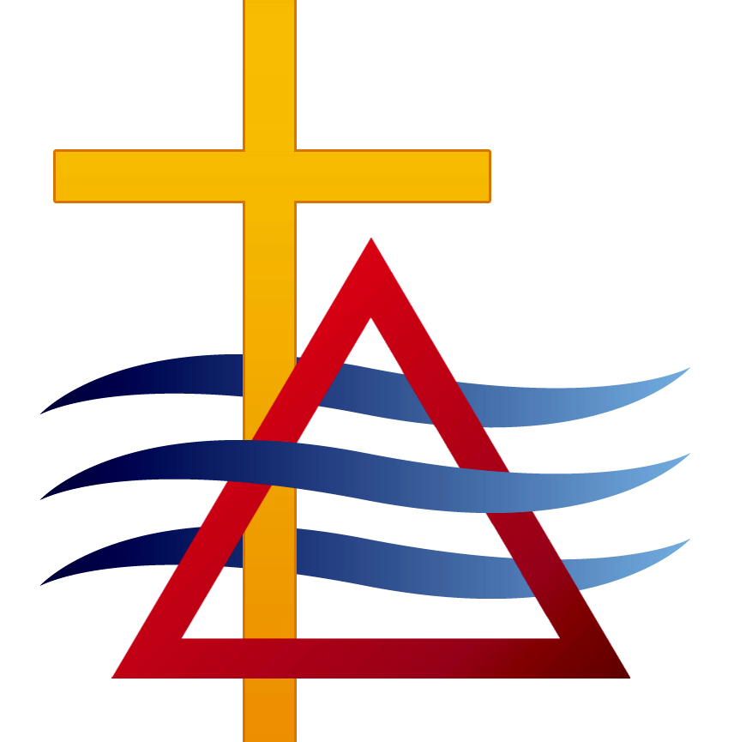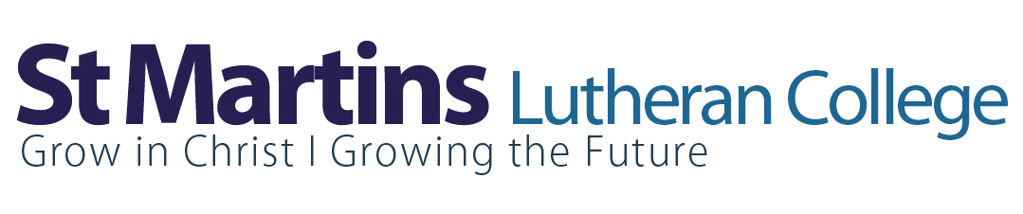

St Martins Lutheran College
Out of School Hours Care

SMOSHC Information



SMOSHC

St Martins Lutheran Out of School Hours Care

Aim
The aim of St Martins Out of School Hours Care (SMOSHC) is to provide a service of after school or vacation care to the children and families of St Martins Lutheran College, in a happy, safe and caring Christian environment.

Rationale
The St Martins Out of School Hours Care program aims to provide quality recreational care for children of school age. It is our belief that the provision of well-supervised care for children in their own College campus is a significant contribution towards our continued support to parents.

Details
Times available:

SMOSHC Hours (After School Care)
Monday – Friday 3:15pm -6:00pm

SMOSHC Hours (Student Free/Vacation Days)
Monday – Friday 8:00am - 6:00pm

SMOSHC Location
SMOSHC House near the staff car park

Children must be registered for the program using the SMOSHC enrolment form available from the College office or the SMOSHC Director.

After School Care - Vacation Care

Due to SMOSHC being a totally self-funded service, it is important that all accounts are paid in full 14 days after date of invoice. Families who use the service will receive an invoice every month.

If you require any further information regarding SMOSHC, please call into the SMOSHC House any afternoon of the school term from 3:00, or phone the Director on 0418 815 101.

After school care generally involves a snack, free time, programmed activities and an opportunity for students to do homework.

Vacation Care involves a variety of structured and unstructured activities, eating times and planned outings.

Staff
Director: Mardi Karsten 0418 815 101

On behalf of the Director and staff of SMOSHC we look forward to seeing you at SMOSHC.

